I had assumed that early April in Northern Ontario was going to be spring-like. We were prepared for cold nights and cool days. The drive was to be long and picturesque but it was also a weather progression for which we were completely unprepared. Snow - everywhere.
This was to be the trip of a lifetime and an experience for which I will forever be grateful. A week driving from Ottawa to James Bay (Chisasibi) with my wife, my two sisters and their husbands!

My name is Bradley Bair and I am a retired teacher, amateur adventurer, father of three, and husband to my incredible wife Marjorie Bair. My life has been about travel and outdoors experiences and I have all the gear to support it.

I was an Ottawa River raft guide in my youth, I hiked up Mount Washington several times, for the 2010 school year my family and I took a leave and traveled throughout South America, in 2019 I rode my bike 2800 km across the northern mountains of Norway and I have driven both ways to the extreme East and West coasts of Canada.

I am the kind of guy who has more down sleeping bags of various weights and temperature ratings than most people have shoes. I also admit that I am a gearhead - I might have a problem!

One of my current fixations is the idea of overlanding. I enjoy driving and I enjoy camping. Overlanding is the prolonged combination of the two but unlike car camping, often involves an off road component. Most Overlanders use Jeeps or Toyota trucks as their tools and consequently the entire overlanding industry is designed for these rigs. I am the proud owner of a Kia Telluride that I bought from the local Donnelly Kia Dealership in Kanata, Ontario.

My Telluride is not designed to be a rock crawler or a serious off roader and I accept that. I push it a bit occasionally and it has never let me down. One of the first modifications that I made to my SUV was to put Toyo Open Country M&S tires on it. This changed my vehicle dramatically and allowed me to push the limits of where we were capable of traveling.

More recently I bought a roof top tent that has allowed us to camp off of the ground and also allows us to travel with enough gear to stay away from home for prolonged periods of time. We also acquired a car fridge that plugs in and gives us the luxury of remaining away from stores for multiple days at a time without rotten milk, melted ice cubes and soggy bread.

My Telluride is in great shape for adventures and it is spacious and capable. The other two vehicles that joined us to James Bay were less conventional overlanding vehicles. One sister drove her Toyota Sienna Van which she prepped expertly for the trip. It had a full sleeping build inside, with a kitchen and an awning. I’ll be honest, it looked the part and absolutely surprised me with its toughness and competence. My other sister drove in her Porsche Macan. This is a capable off-roader but it is small and potentially expensive to repair. They had minimum gear and with a mattress and quilt, were able (somehow) to sleep inside.

On Saturday April 13, 2024, we left Ottawa, loaded with gear, food and supplies and drove straight north through Gatineau and on to Maniwaki. We stopped in Maniwaki for the requisite St Huberts lunch, only to wait for two hours for our food. This seemed like an inauspicious beginning to the trip and it definitely made time an issue.

The next part of our adventure was the long almost straight northern, rain soaked drive toward James Bay. Our weather was a steady downpour and the scenery was typical northern boreal forest. The surprise came when the snow appeared as we progressed north. Where we lived in Ottawa, the snow had disappeared for at least two weeks. North of Maniwaki the snow was in small patches or hinted at with frozen ice on rock faces. Later it was everywhere. Soon we were driving through white outs and near blizzards. We had planned to camp off grid on this trip but the weather was to change everything and wild camping was to become very difficult.

Despite the snow, we eventually found a great space to camp and enjoyed a fire cooked delicious steak meal. It was a nice campsite near La Corne Quebec and we enjoyed a purple, red sunset overlooking a spectacular frozen lake. We sat around our warm campfire and enjoyed our freshly prepped camp food. The lunch time delay actually made dinner time better as we would have likely missed the sunset if we had pushed further. We slept well feeling lucky but also concerned about the snow and the implications for the next phase of our Northward push.

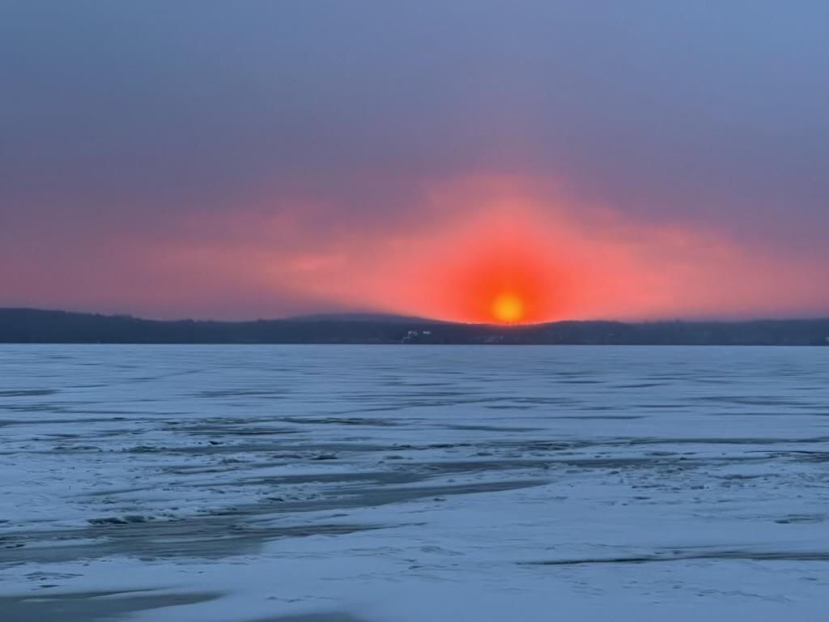

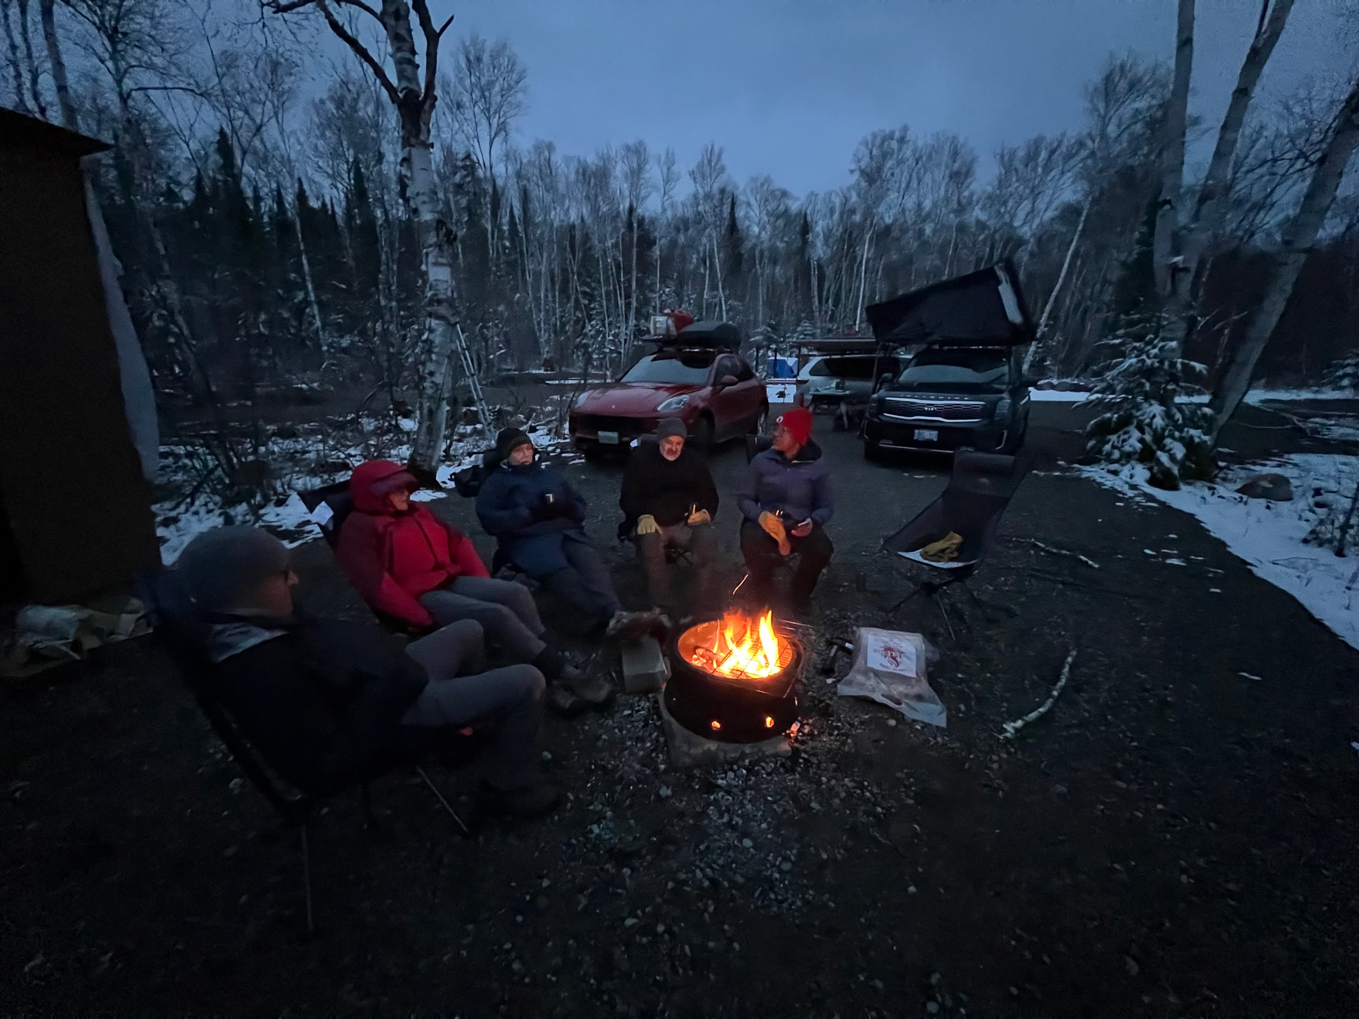

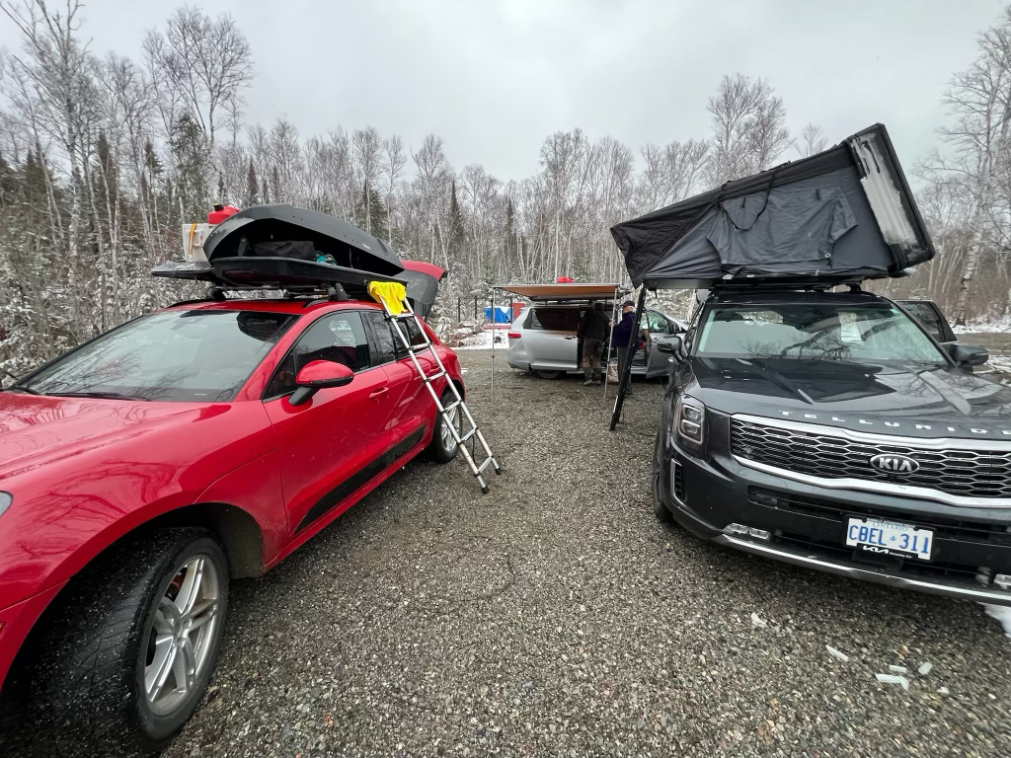

Day two was a slow start as we all figured out our camp systems and packed for the road. Eventually we drove through the snow to the main road and began the next phase of driving into more falling snow and northern weather. We resupplied some small items and grabbed some groceries in Amos and continued north.

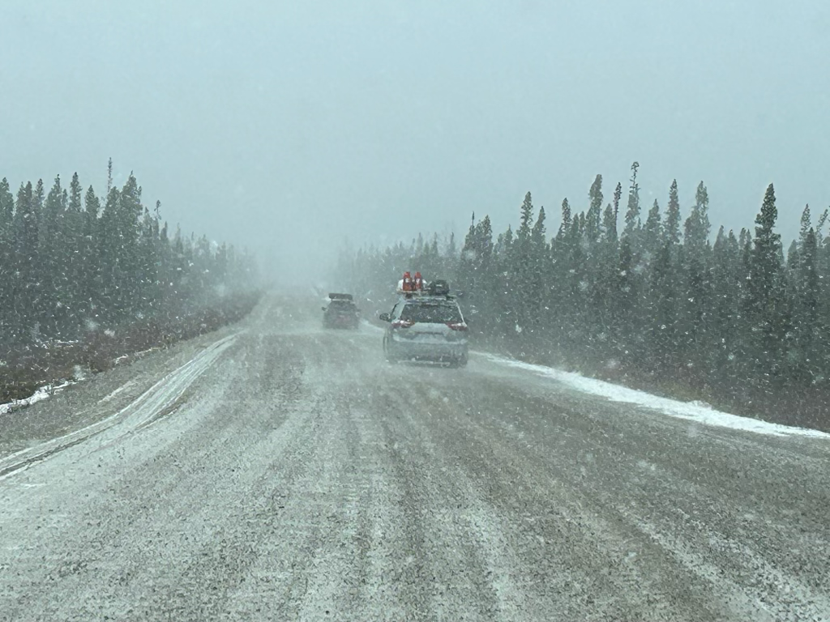

Then, just as we began to find our driving rhythm, the dramatic gates of the Billy Diamond highway appeared. This is a famous road where you are required to check in and where there are warnings about having sufficient gas as the resupply network beyond here is very sparse. We had prepared for this and each car was carrying two Jerry cans worth of gasoline (I had built a hitch mounted carrier for my Jerry cans, affecting my steering a bit) and both other vehicles carried their gas on the roof rack.

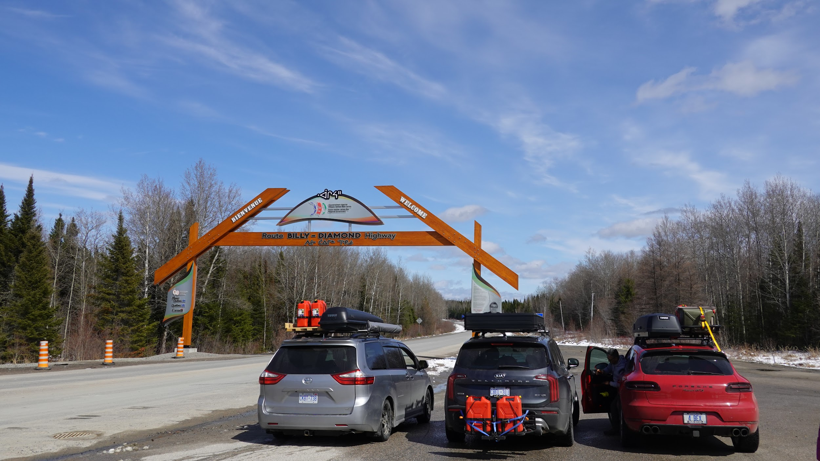

After checking in, we had our lunch at the gate entrance and then continued north. This is when the landscape began to change from typical Boreal forest to Taiga. The landscapes changed from Birch at first to Black Spruce and rock.

The tragedy of this road trip is the destruction caused by previous years wildfires. The strange beauty that remains is startling. The black and rust colour of the burnt and singed trees creates an austere but almost minimalist appearance in contrast with the snow. We had come at a good time to see this decimated place in its best light!

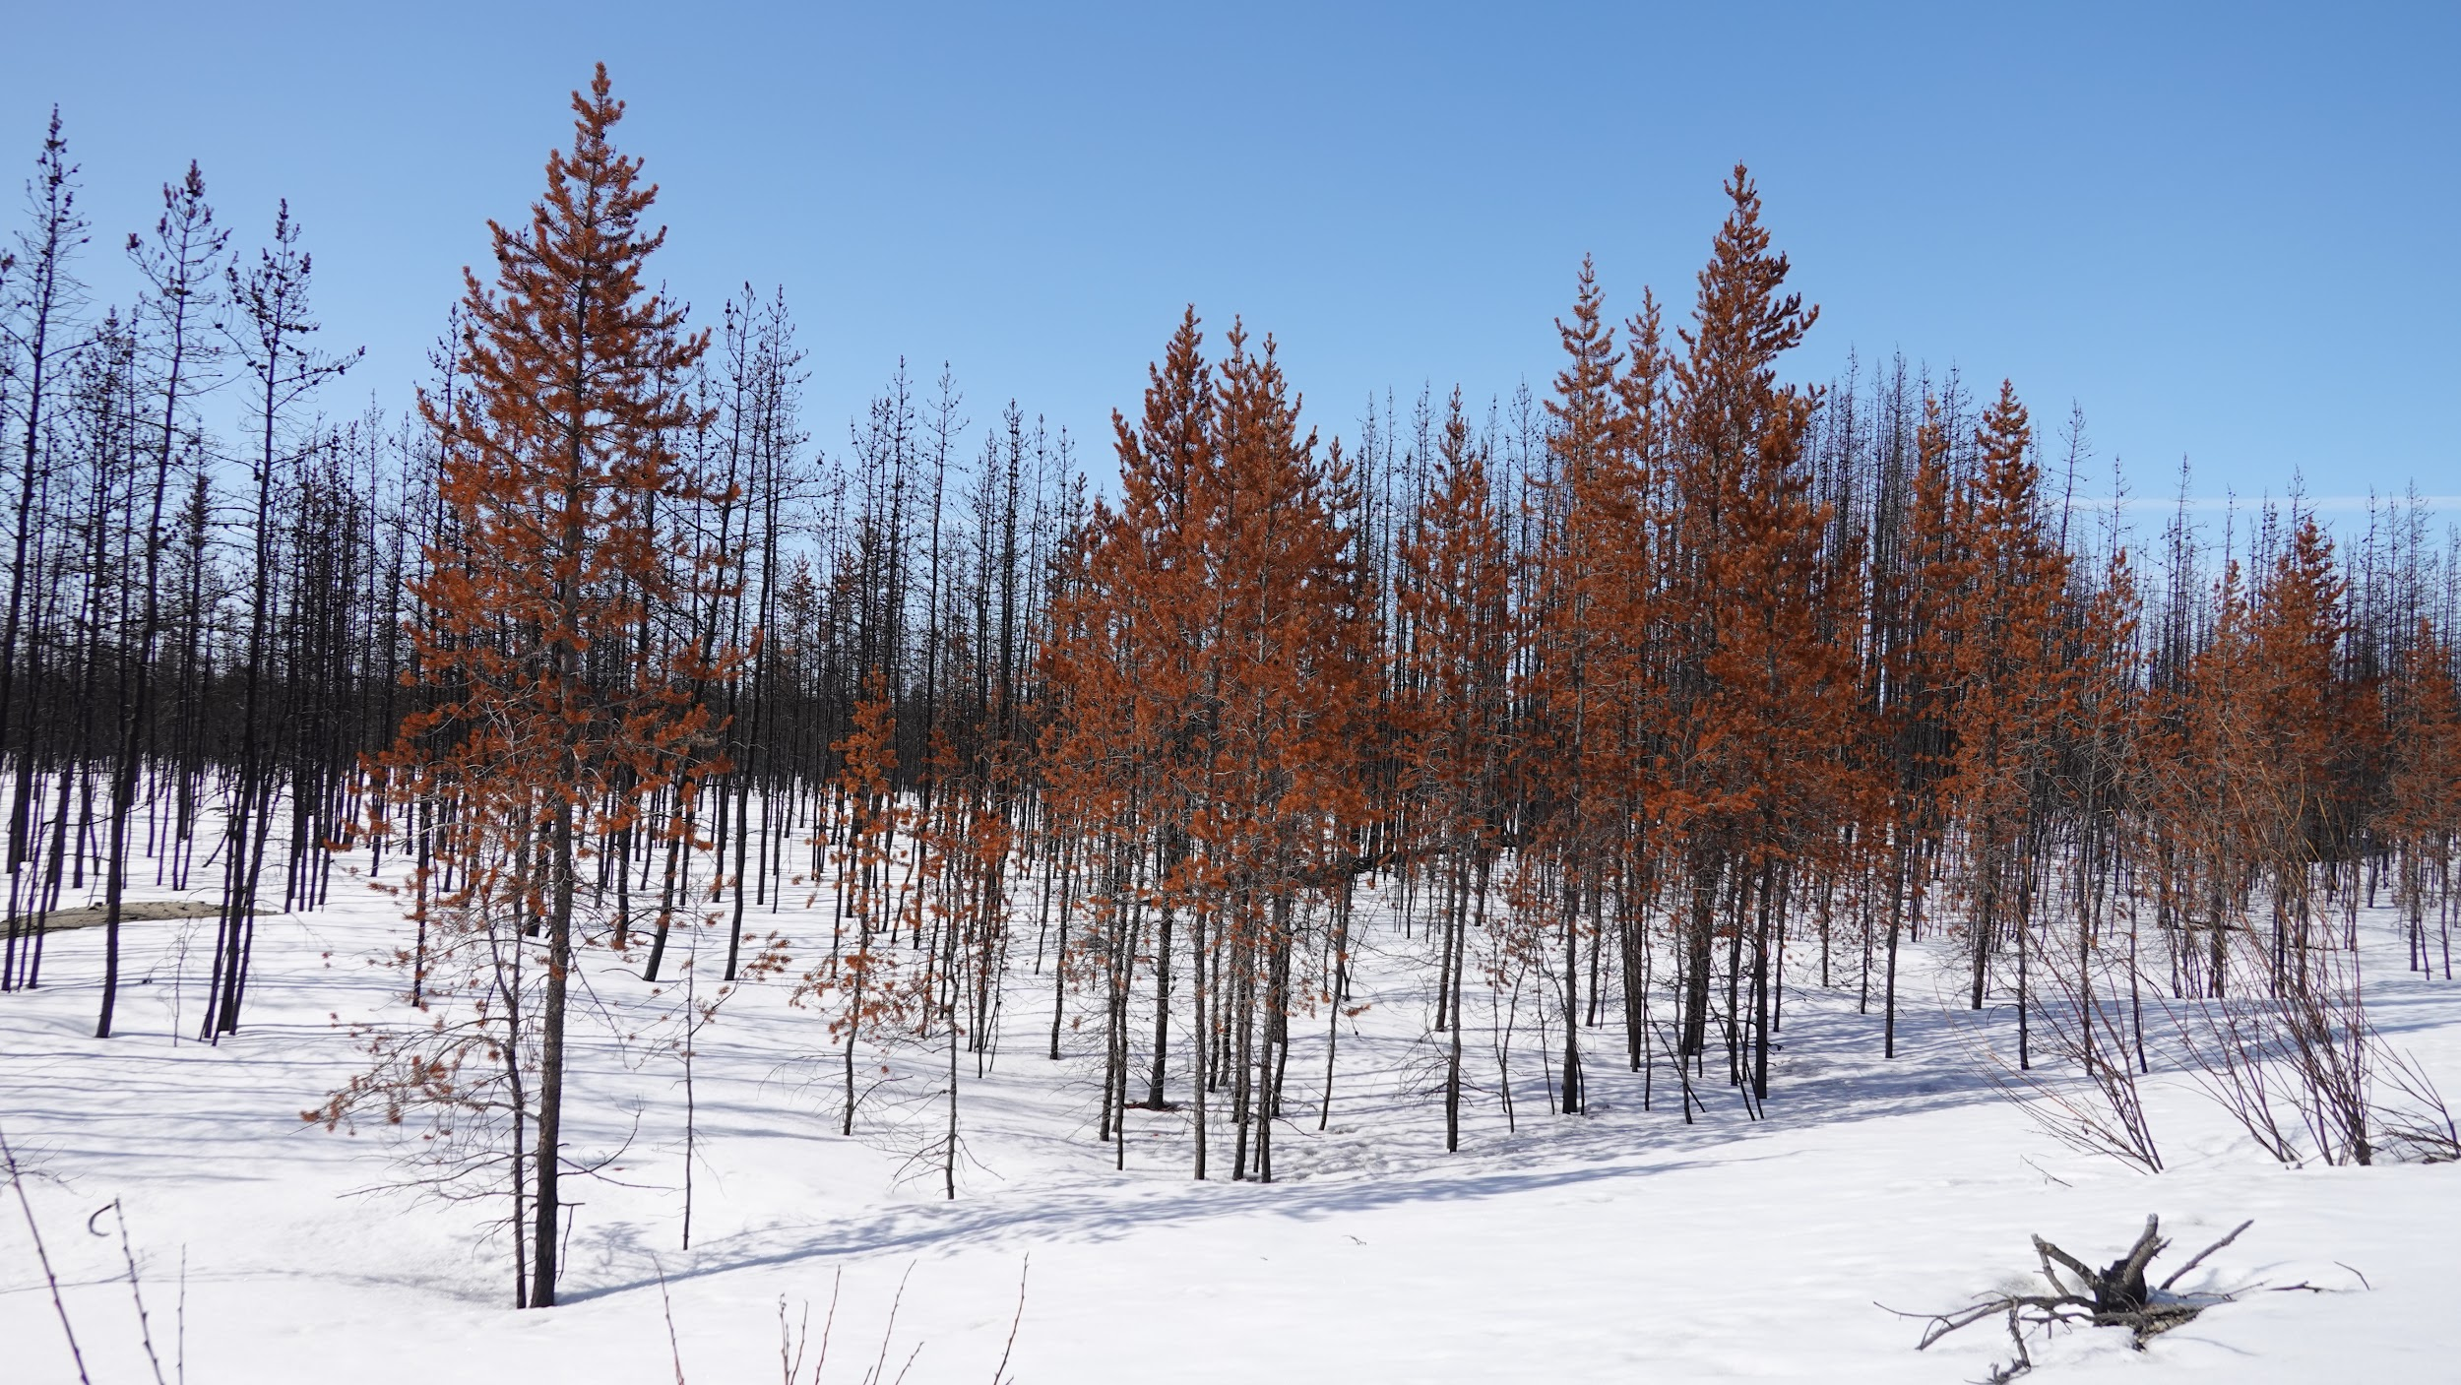

As we drove north we realized that all of the official camping spots were not open and were too full of snow. We laughed out loud as my sister and husband tested a side road in the Porsche. The soft, deep snow nearly claimed them and I was genuinely hopeful that I was going to be forced to use my recovery gear and the mighty Telluride to rescue them. Fortunately for them, they drove out unscathed and with their dignity only slightly tarnished.

We continued on towards Waskaganish and eventually filled up our gas tanks at the one available gas spot. Here we grabbed some food and hit the road north. As we turned off the main road towards Waskaganish, the burns become even more commonplace. The road was gravel and the Telluride loved it.
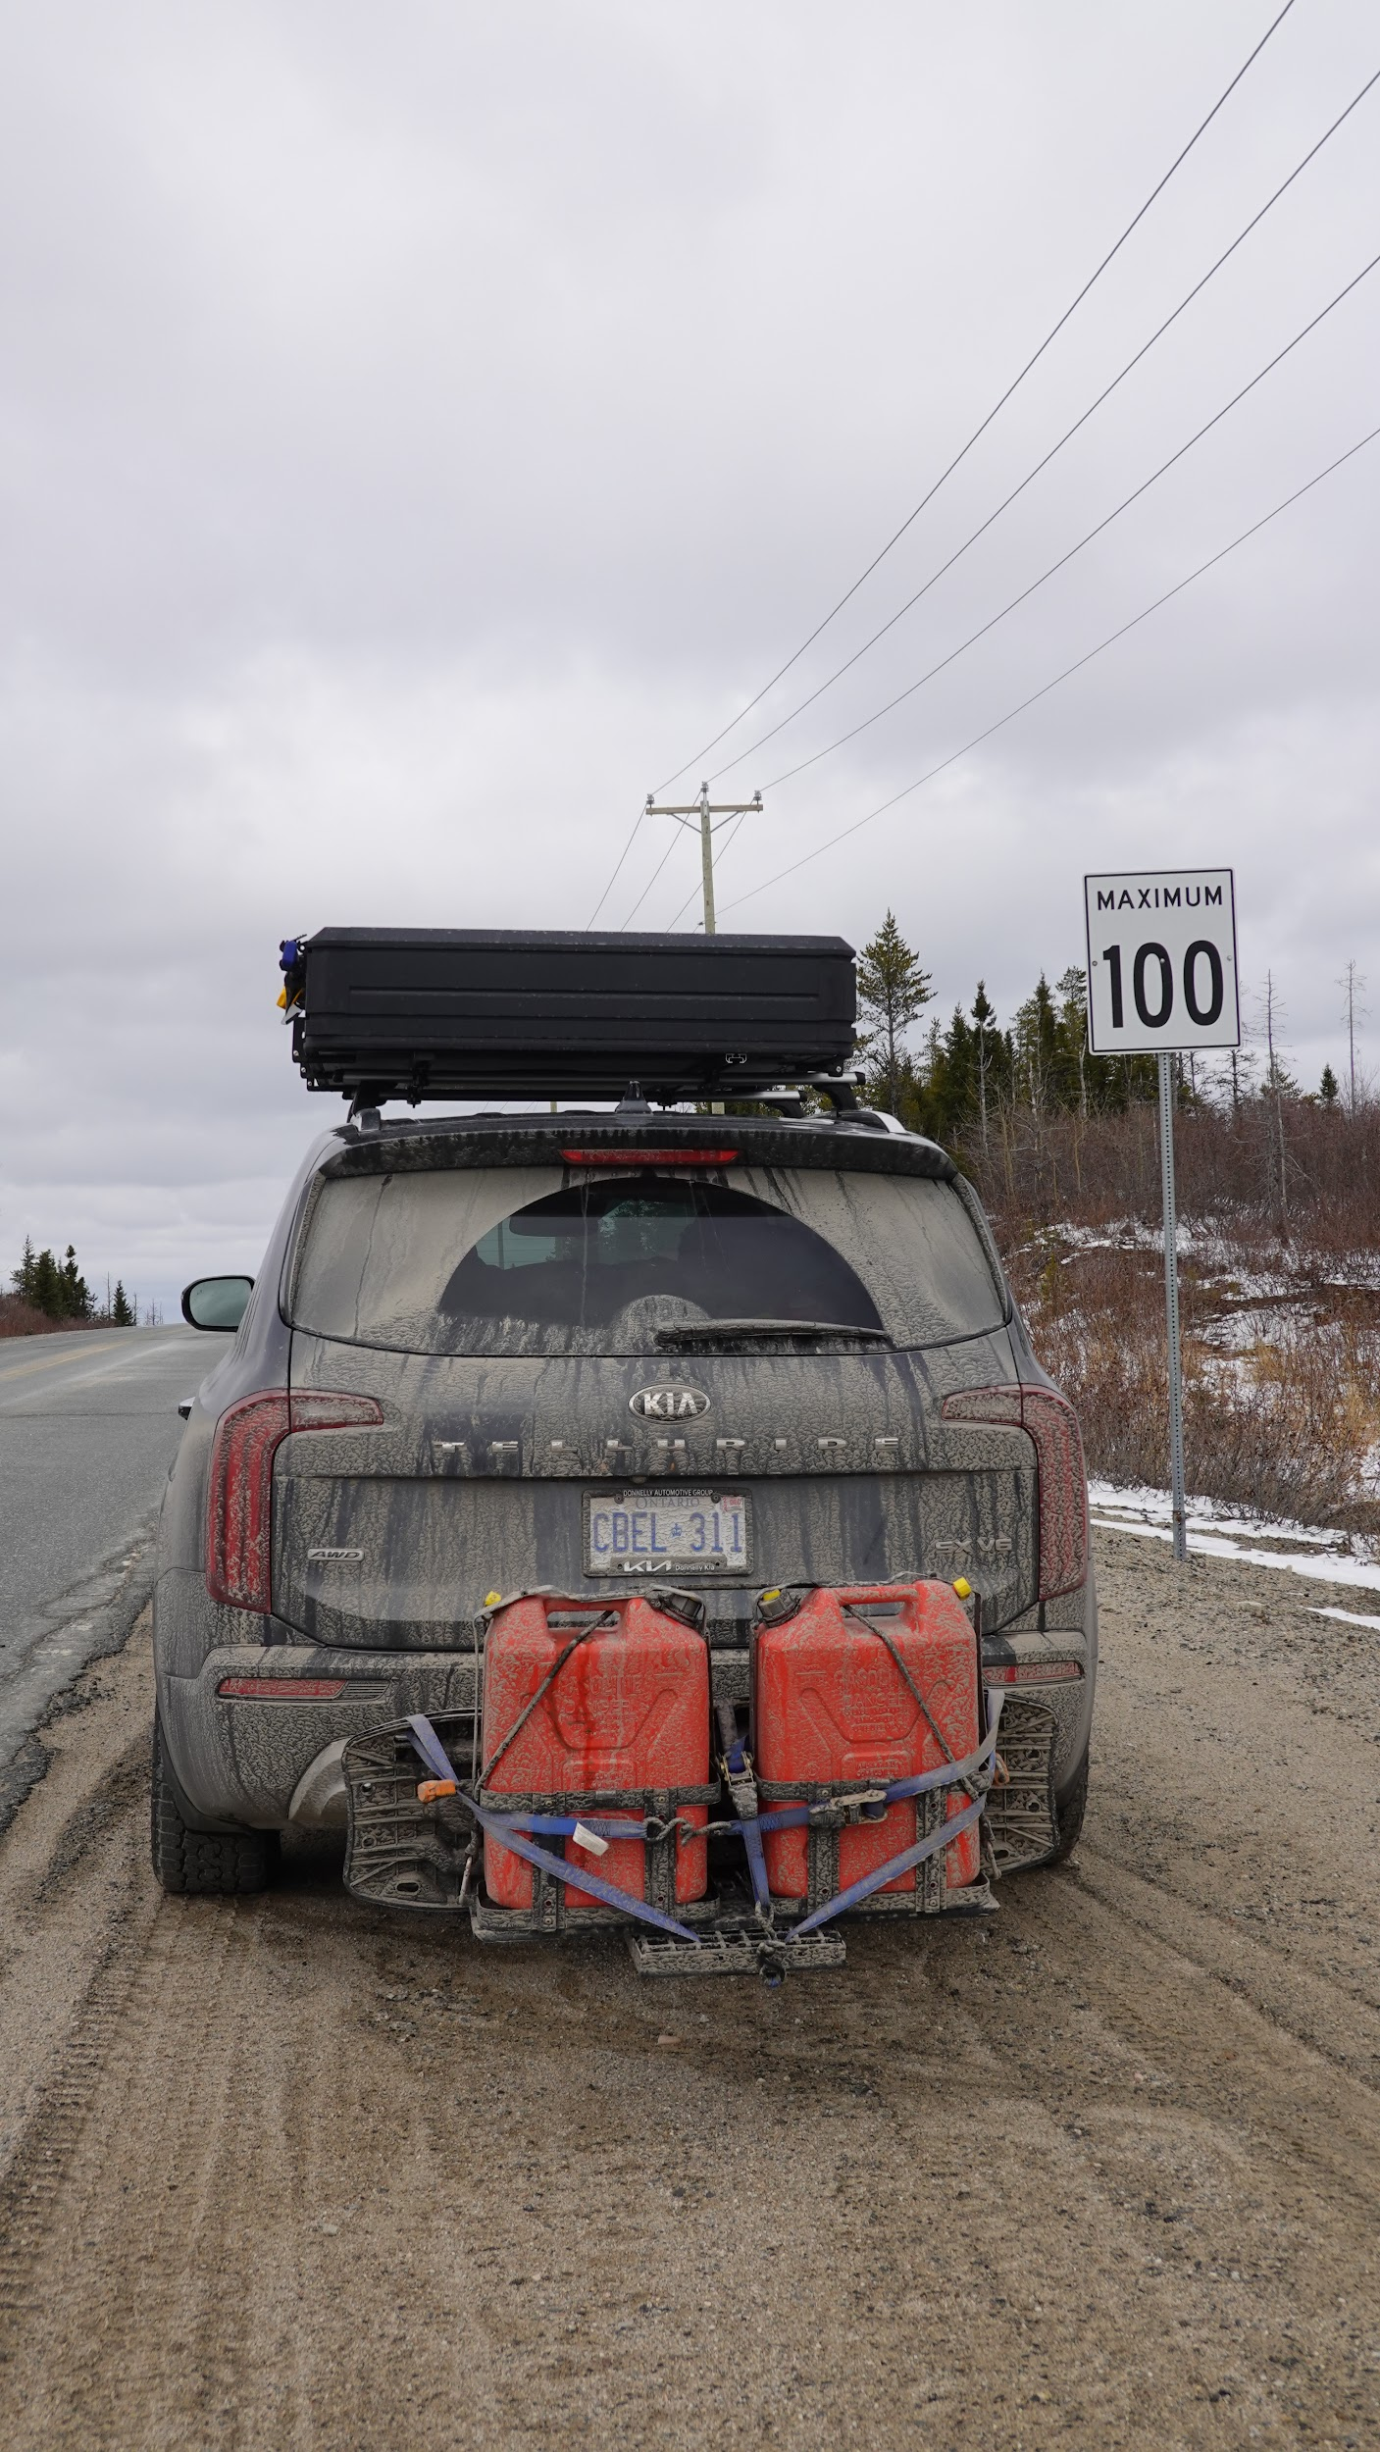

We drove towards town slowly and it was becoming clear that we needed to find a camp spot. We drove down several side roads to no avail. In our pre-trip research we had read about overlanders using gravel pits on this route and we finally found a large open pit with space for all three vehicles to camp.

We set up in the cold and we cooked a meal under the Sienna’s awning. The sun set and the mood was perfect. That night we slept, in cold satisfaction, knowing that wild car camping was indeed possible in this snow covered country.

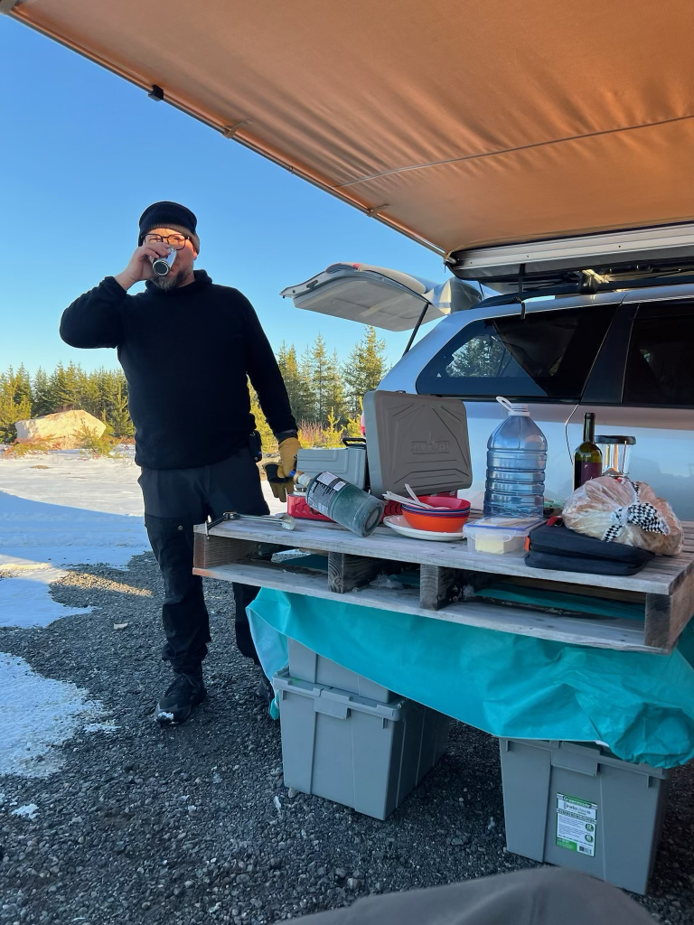

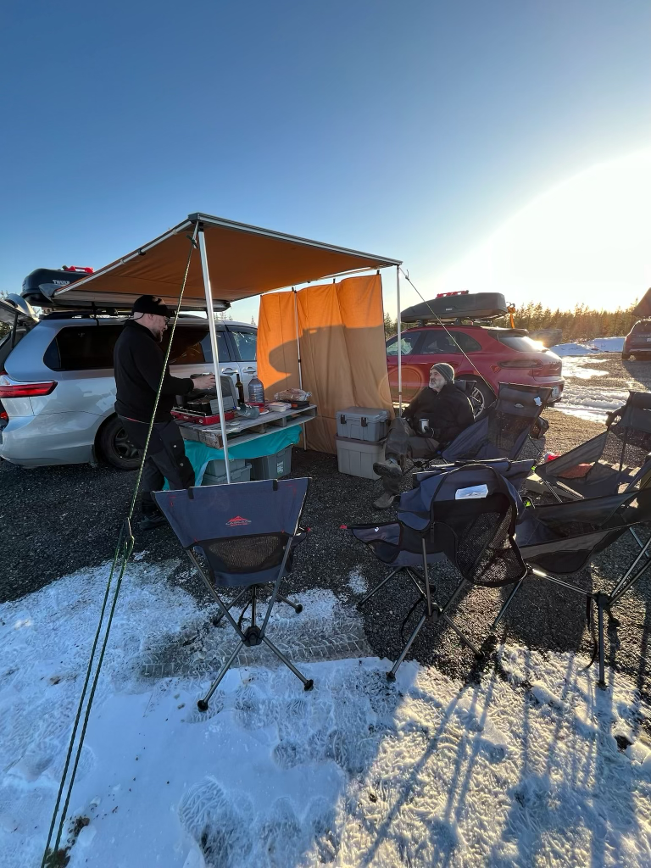

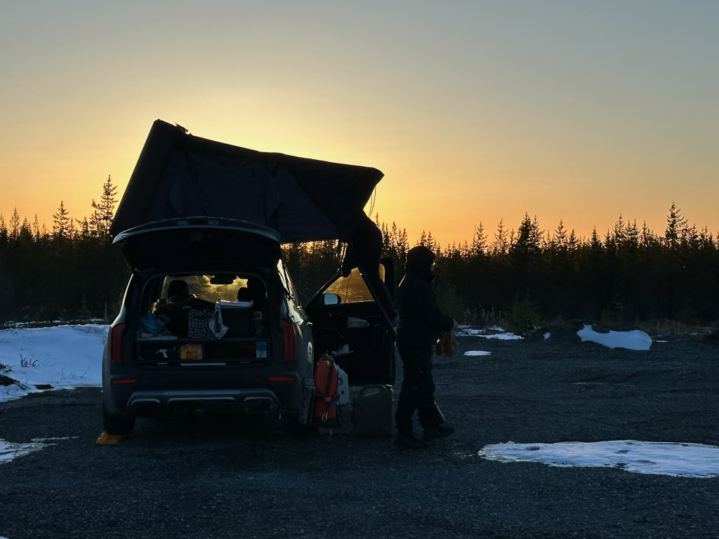
The following morning we awoke and hit the road early and went into Waskaganish. This town is small and very quiet. It is obvious that the influx of money from the hydroelectric projects around James Bay has enabled a decent lifestyle for the Cree people of the area. The town is well maintained and we enjoyed a delicious breakfast here.

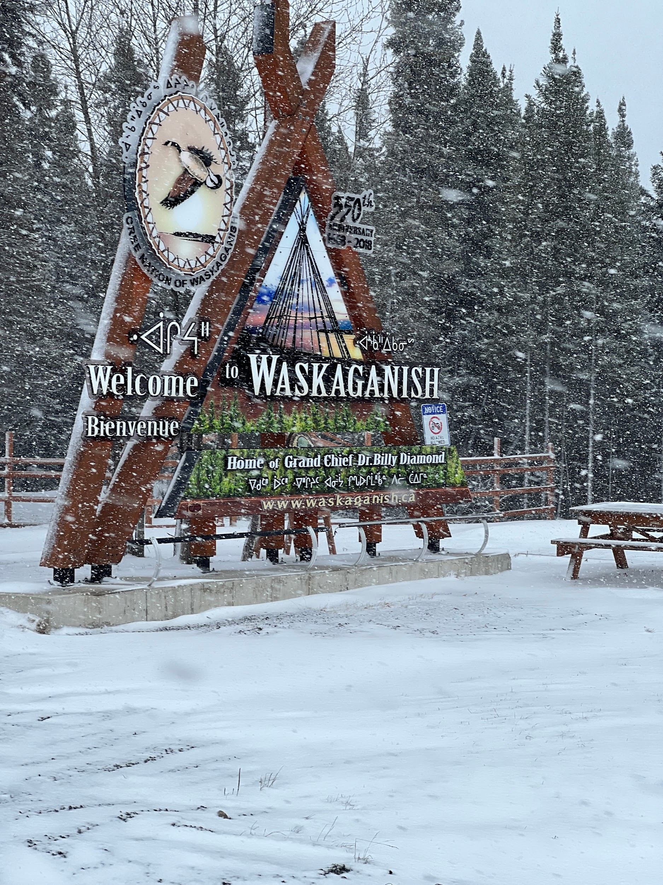

Despite the fact that I try to be aware of cultural nuances, I suspect that I was subject to some of the northern stereotypes. This trip was to flip a lot of those ideas on their heads. I was surprised at how outgoing, friendly and welcoming the people were (as I carried some guilt for coming north as a tourist). We were aware of how few southerners traveled up here and we knew that this was not the “tourist” season. As a result we were determined to leave some money in the communities and we hoped to at least come home more informed by asking questions and seeking truth. We assumed that there would be some resentment and hostility towards us. There might have been, but we did not feel it. We were greeted by curious men and women who asked us about our lives. I left this town feeling like we had shared and that the exchange was balanced. In some cases, we were obviously the spectacle and they were the researchers and as a result the conversation did not end up feeling exploitative or one sided. It was also clear that the people of Waskaganish knew a lot more about people from Ottawa than we knew about them!

We left Waskaganish and headed back to the main road to continue north. We were hit by more weather and snowy conditions. After hours of driving we found ourselves in the tiny town of Radisson, Quebec. It was here that we realized that the snow would prevent us from camping. Fortunately the Radisson Hotel, a hotel for the Hydro Quebec employees, had a very expensive set of rooms that we were able to use. The restaurant at the hotel was closed and we were forced to problem solve. We heated up our food with our camp stoves in the parking lot and ate a delicious meal in the hotel common room.

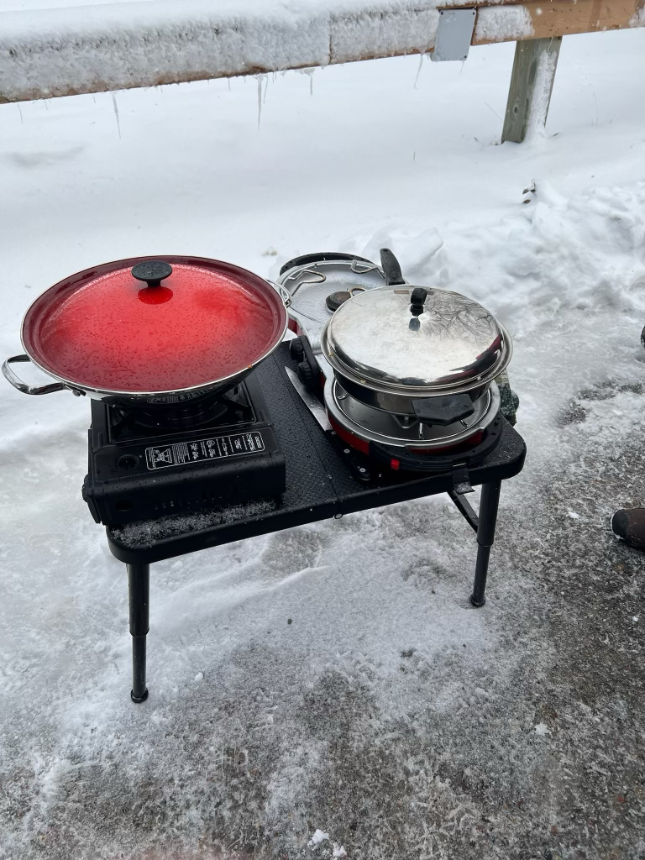

The next morning, we visited the Radisson gift shop which sold indigenous art and clothing from Canada’s north.

We then visited the epic and controversial hydroelectric installation where we climbed a watch tower and surveyed the kilometers of intensive damage done to the landscape. The road to the project was inundated with ptarmigans, the snow white grouse of the north. These cute animals lined the road and trees along the route.

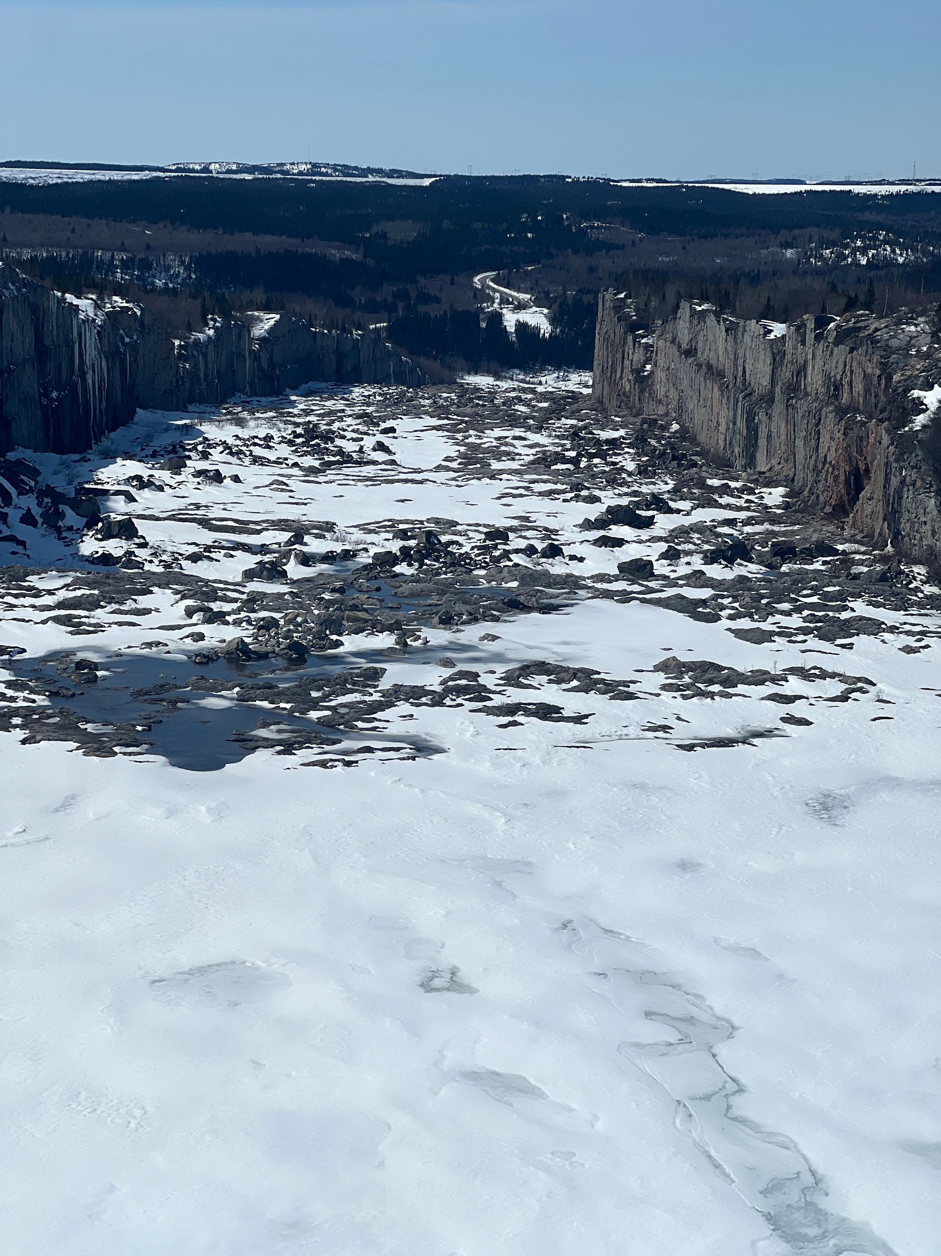

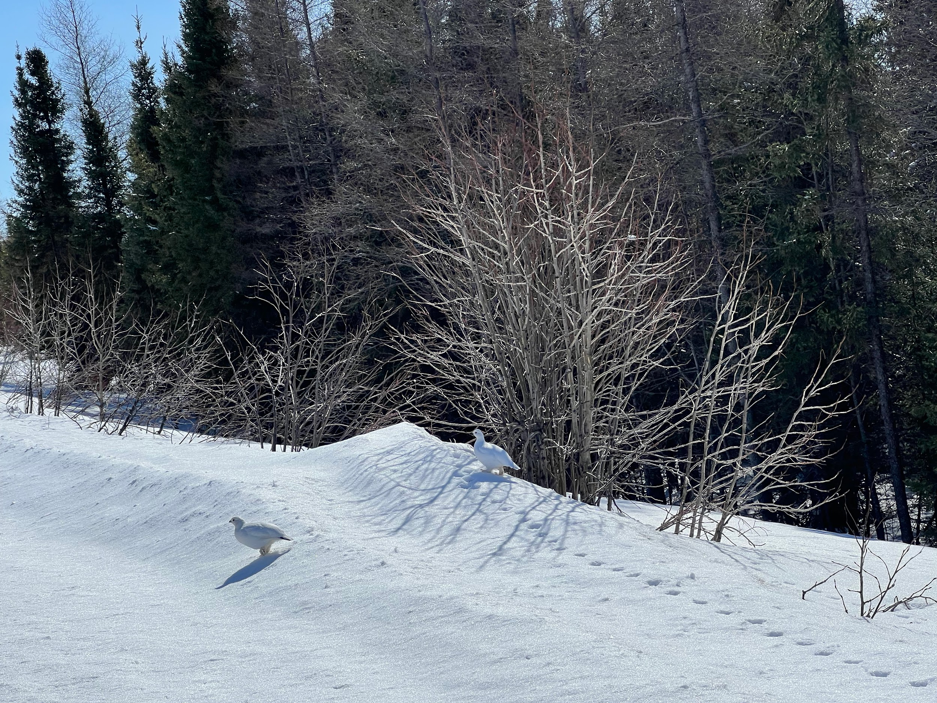

This morning was our ultimate day.
We hit the road again for Chisasibi. This was to be yet another gravel road, albeit a very smooth road that took us to the coast. Here we ventured further to the inlet that was connected to James Bay. We had reached our destination and it was beautiful. The sun was shining and the snow reflected the bright light over the huge expanse of ice covering the bay. We took many pictures and celebrated the achievement. It truly felt remote and exotic. The end of the northern road.
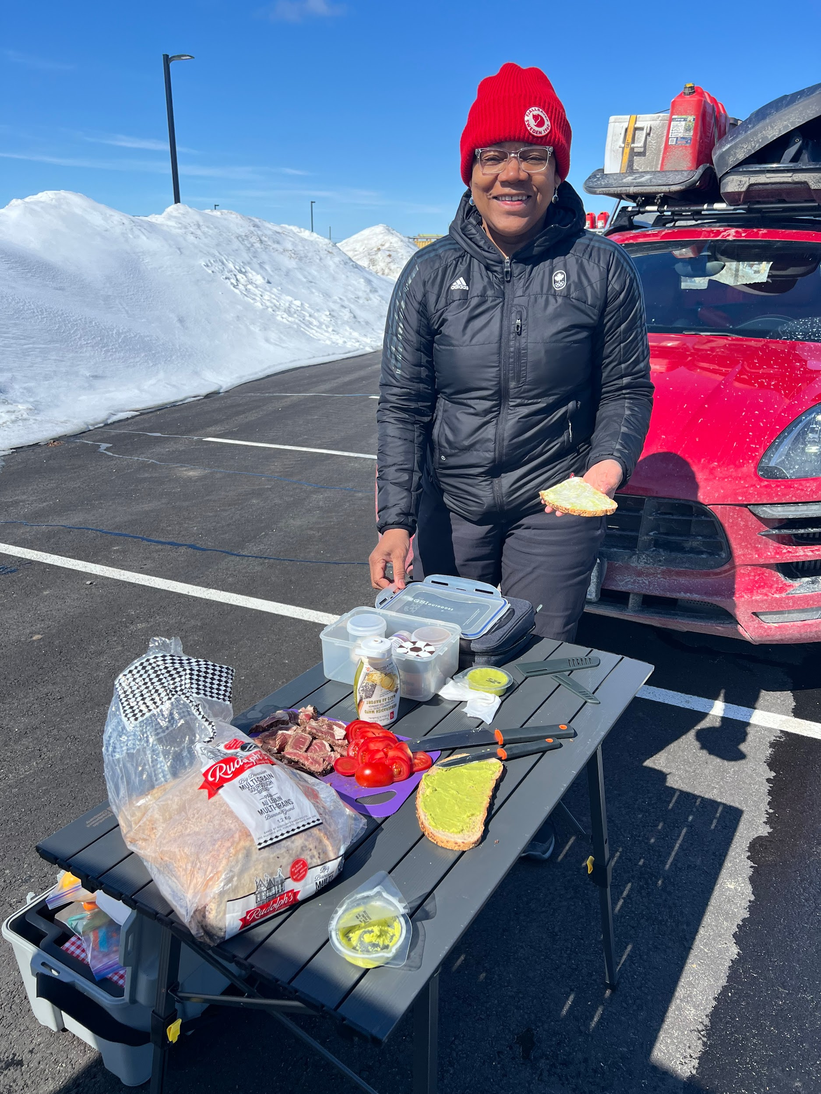
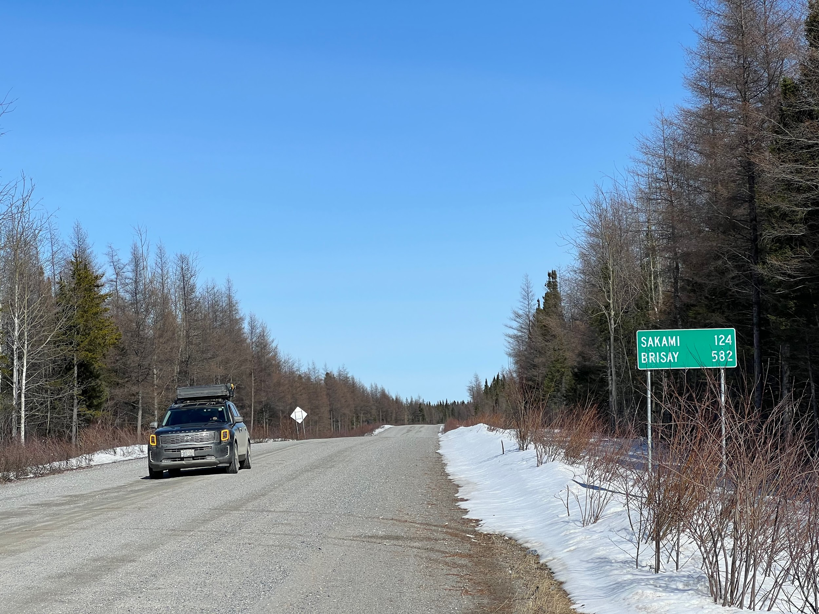

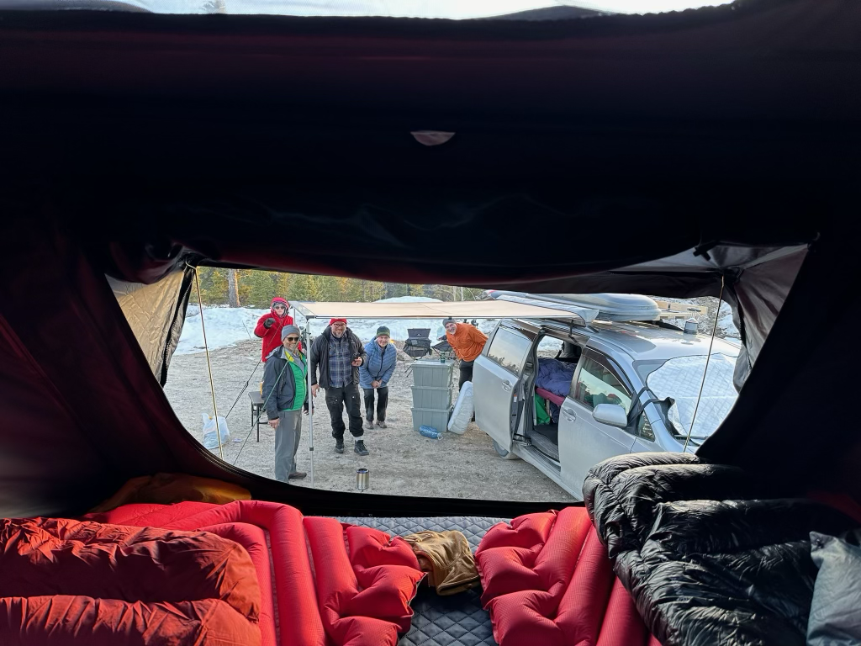

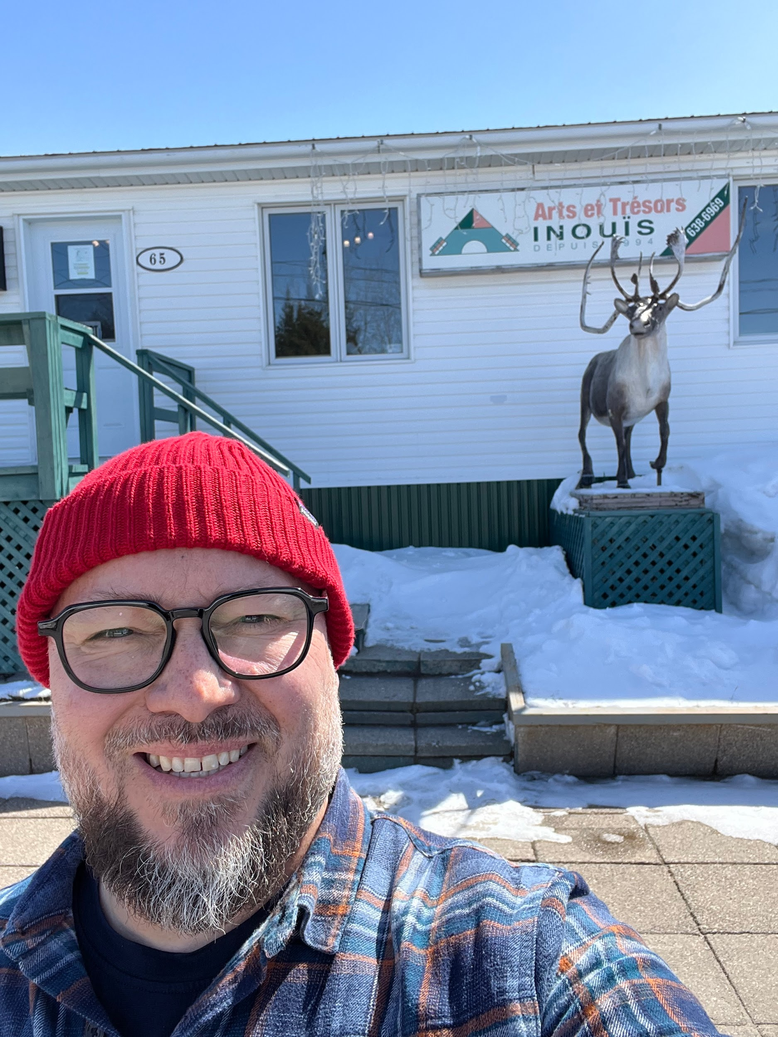
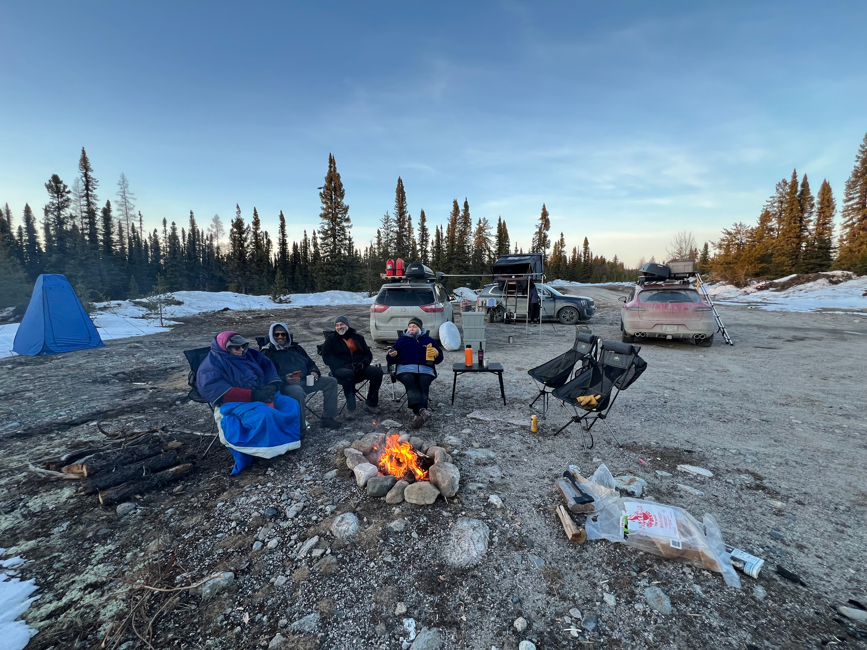

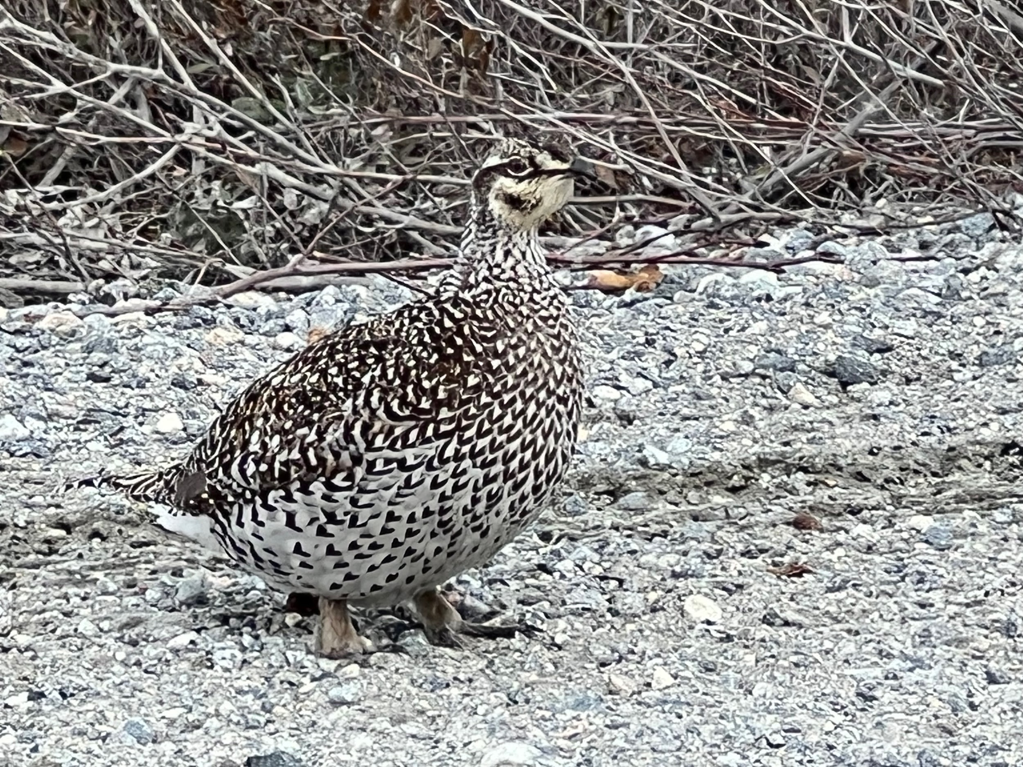
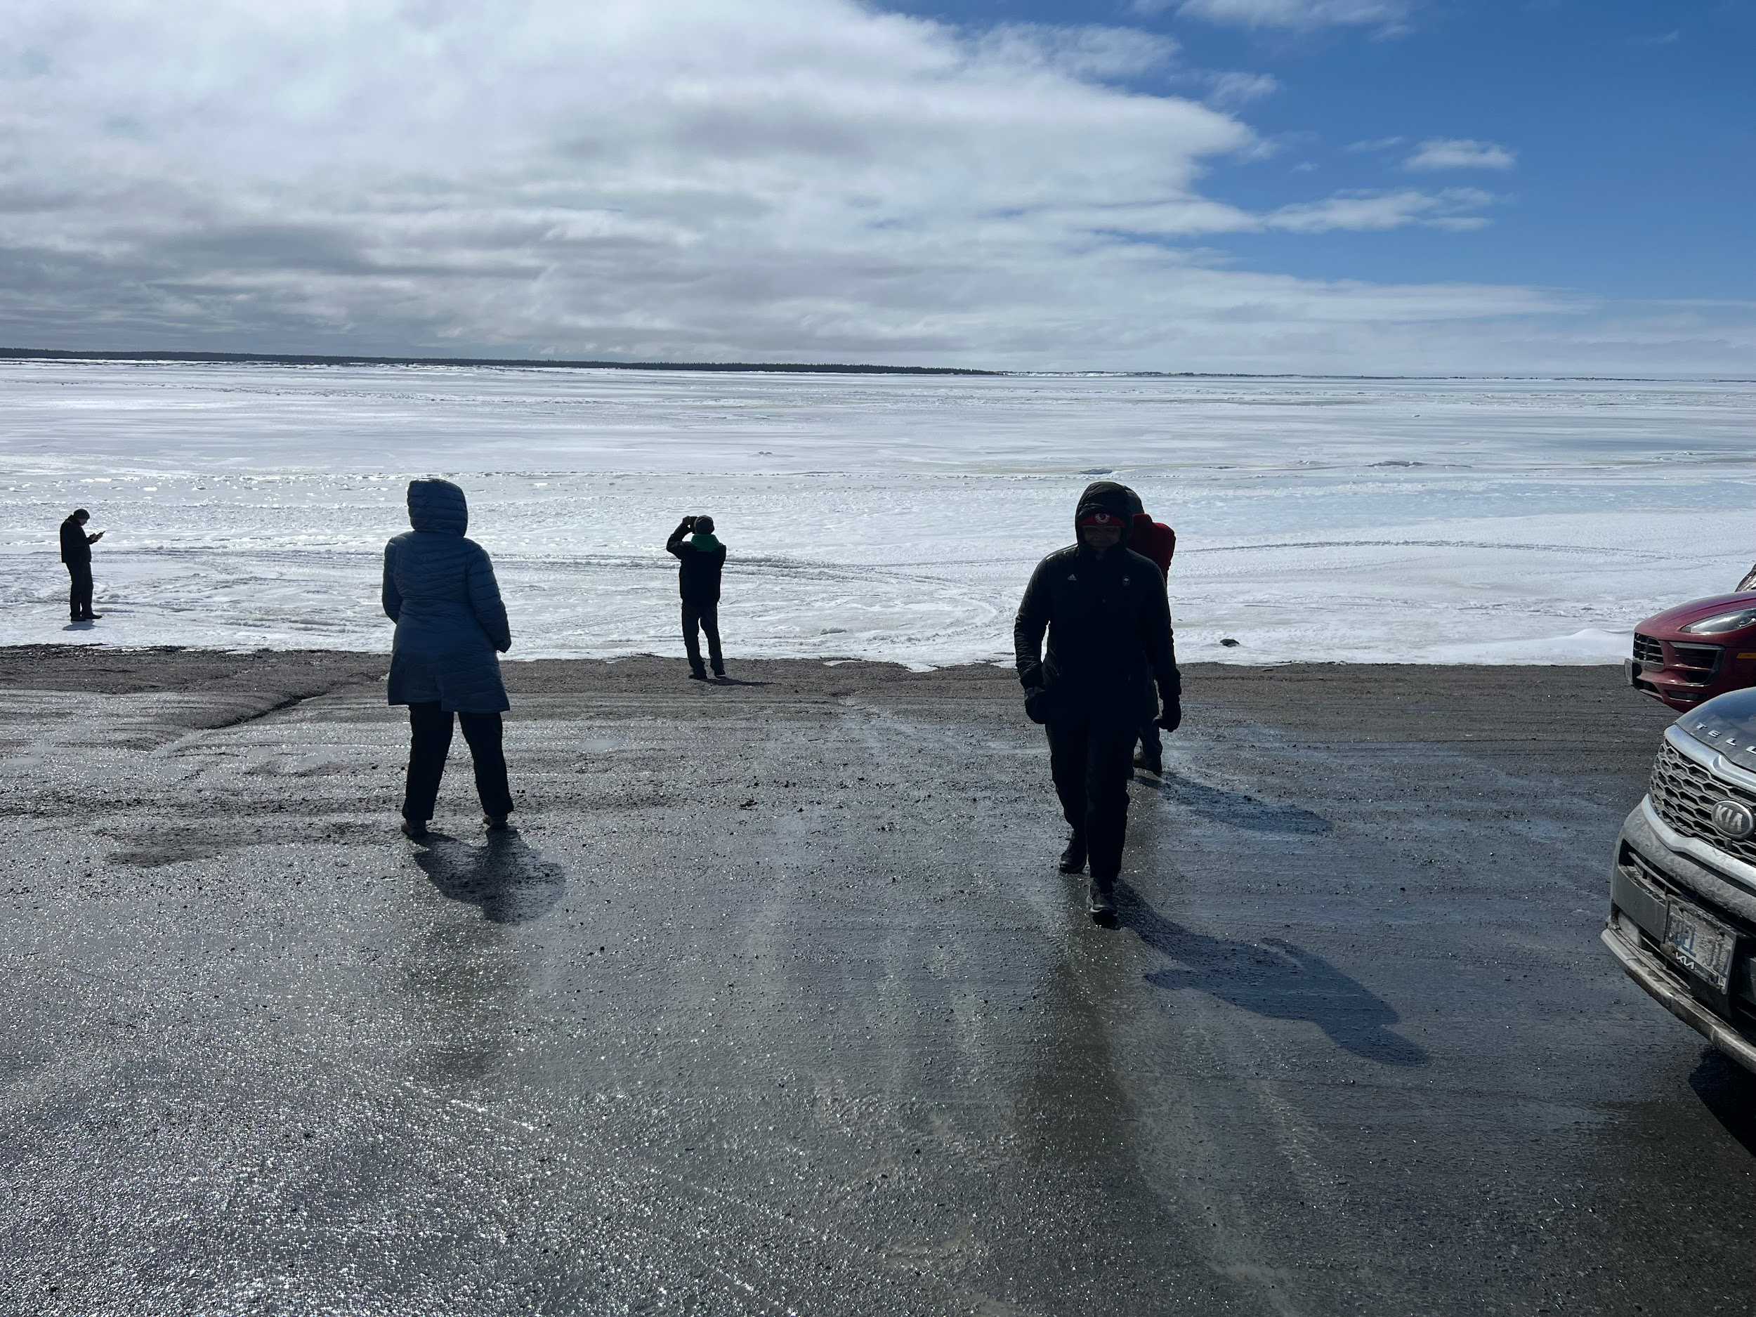

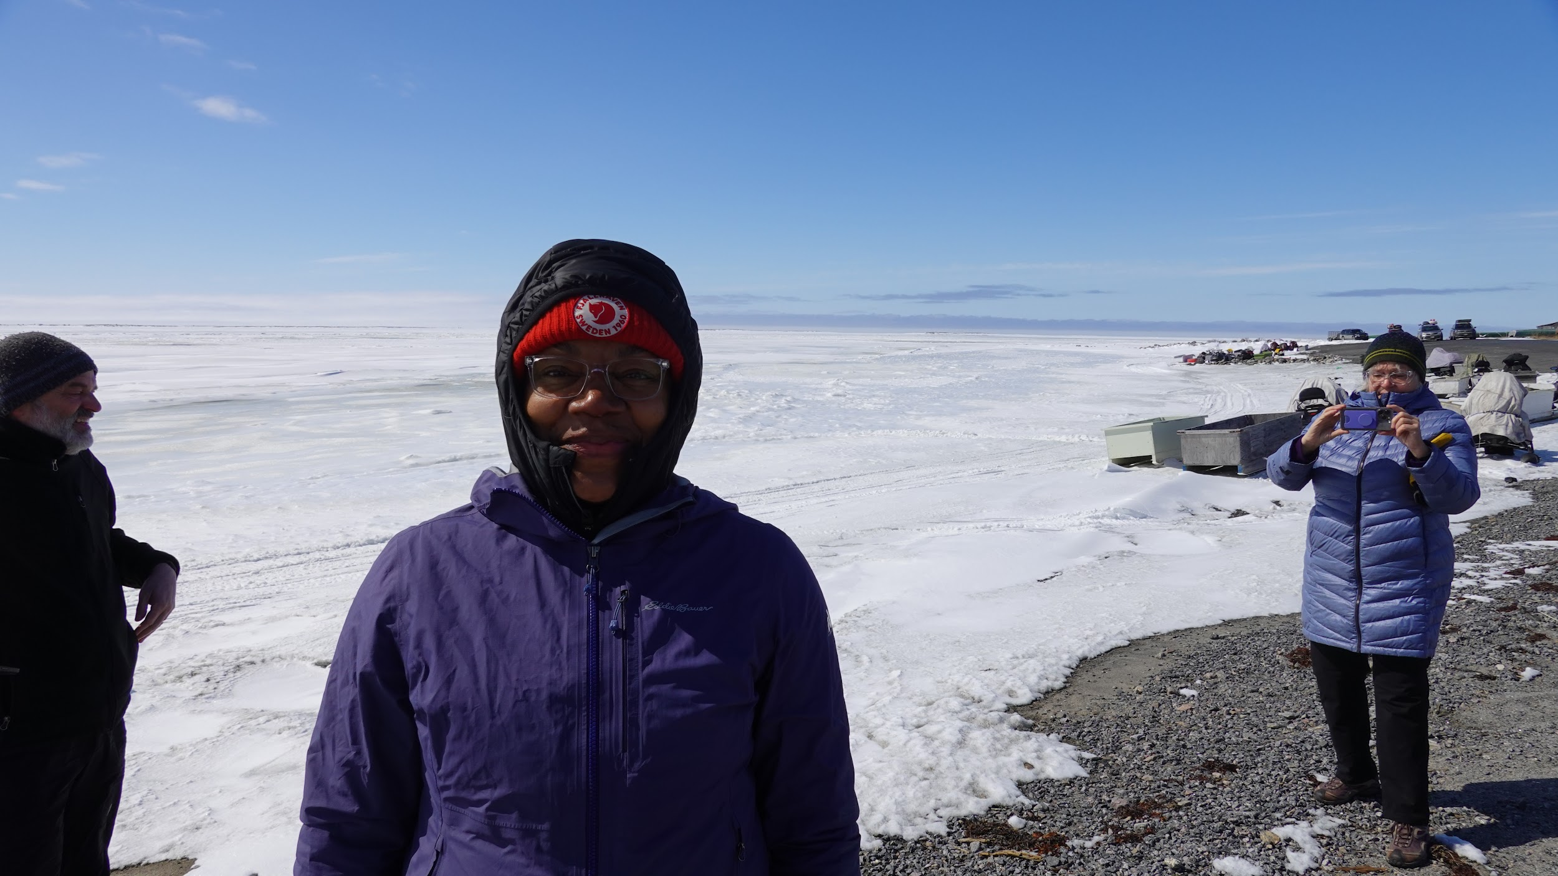

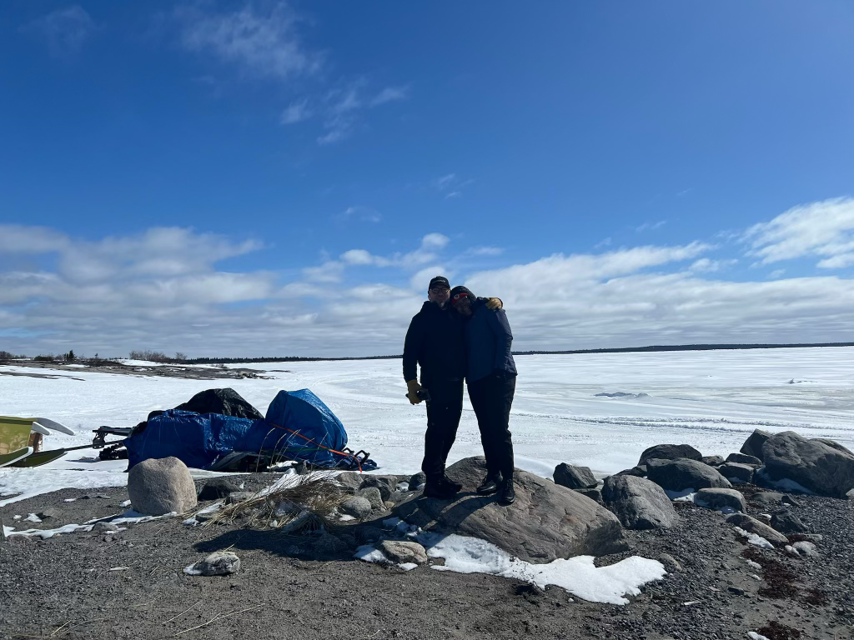
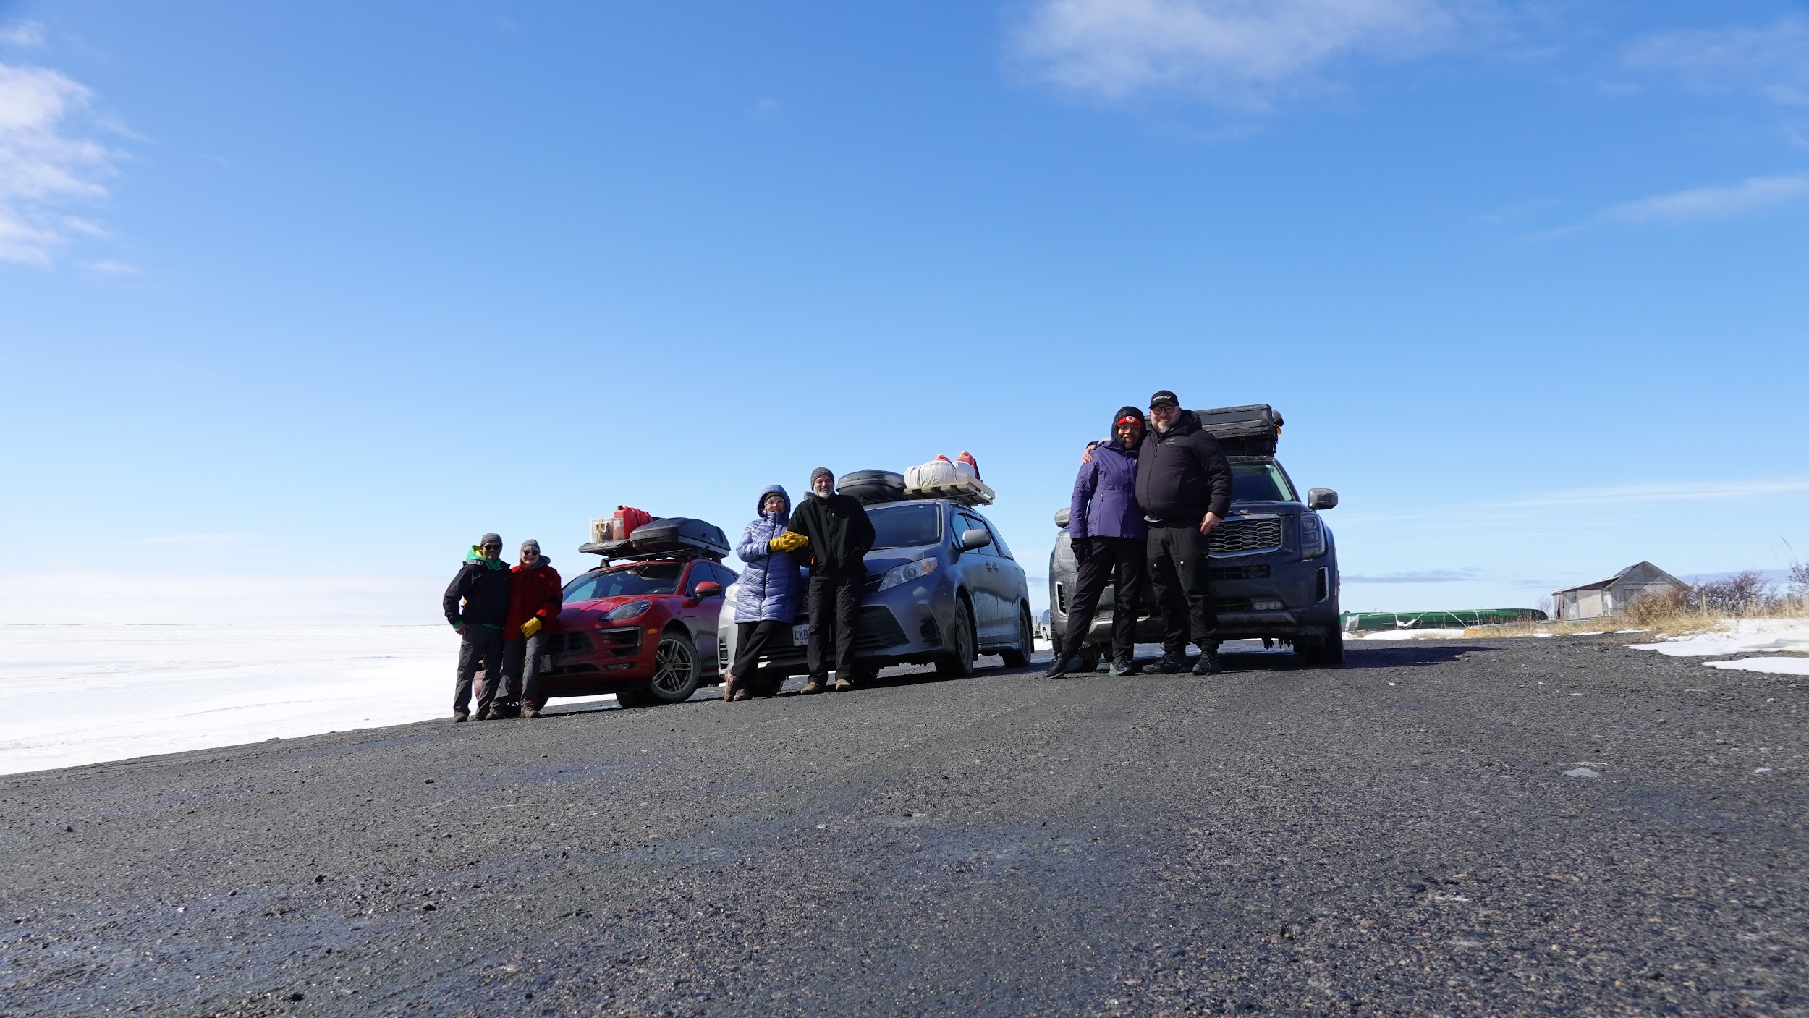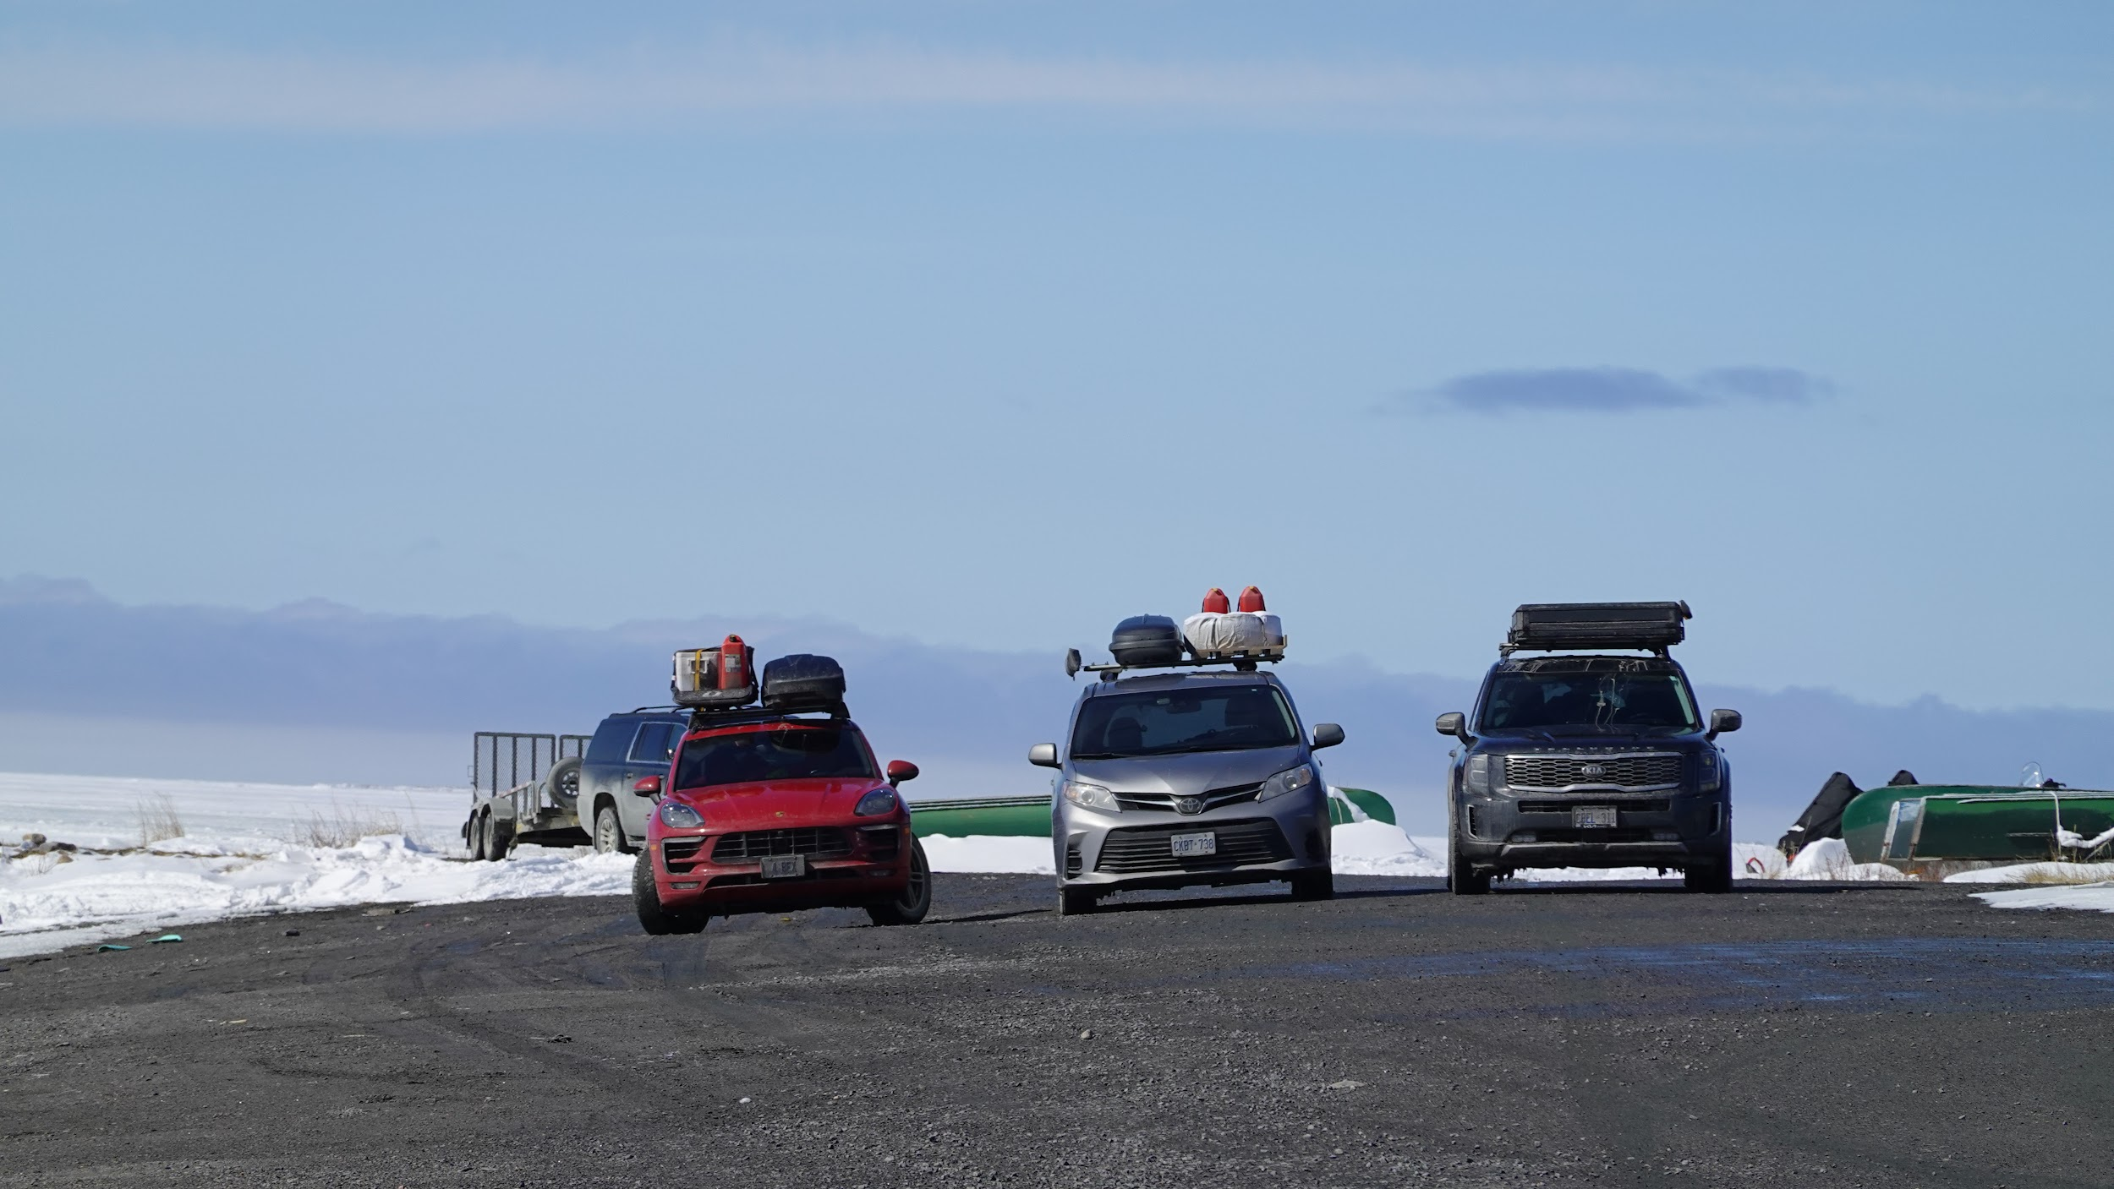

Road trips are sometimes hard and can be a challenge. Traveling with family makes it much more palatable. This trip to the north taught me a lot about my own purpose. The destination is not the point, it is not the objective. It is the solving of problems as you go that makes it all exciting and rewarding. The snow, the cold and the challenge of camping as we traveled, all contributed to a great sense of accomplishment. Navigation and food preparation made it even more impressive. The cultural experience made it all the more worthwhile.
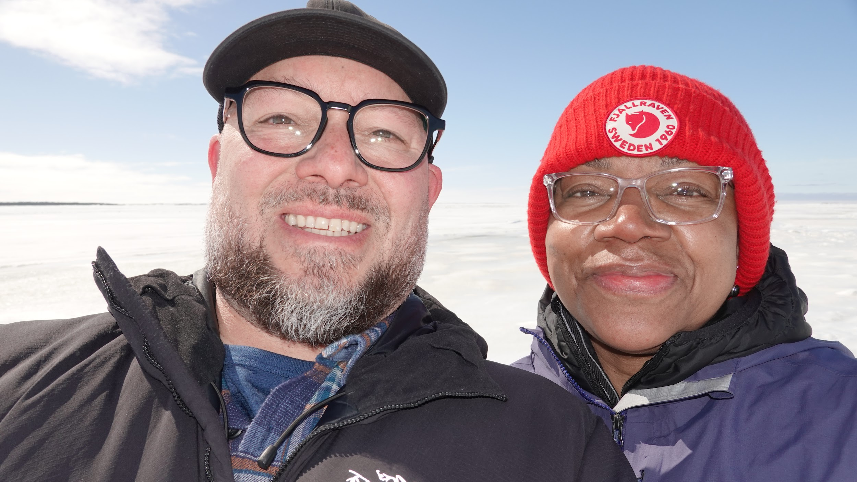
Until the next adventure in our overlanding Telluride!

